JAVA 8
Java 8, released in March 2014, introduced major new programming features to the Java language, bringing functional-style programming capabilities and many performance and productivity improvements.
- Functional Style Programming :
- Functional style programming is a programming paradigm where functions are the primary building blocks of a program.
- It focuses on what to do, not how to do it, by emphasizing pure functions, immutability, and declarative code.
- Functional style = Declarative + Pure Functions + Immutability + lazy.

- Imperative vs Functional Style in Java :
Imperative Style (Traditional Java)
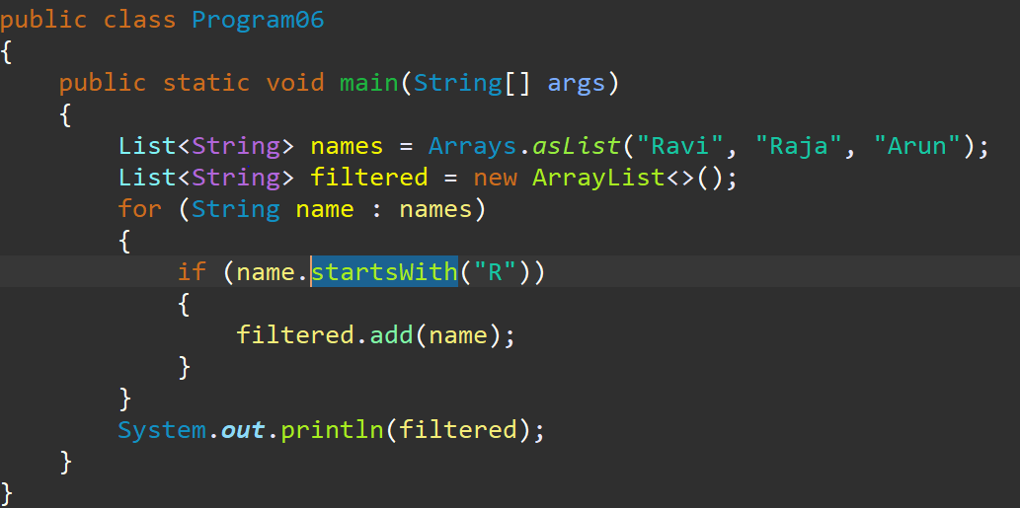

- Functional Style (Java 8+ with Stream API):
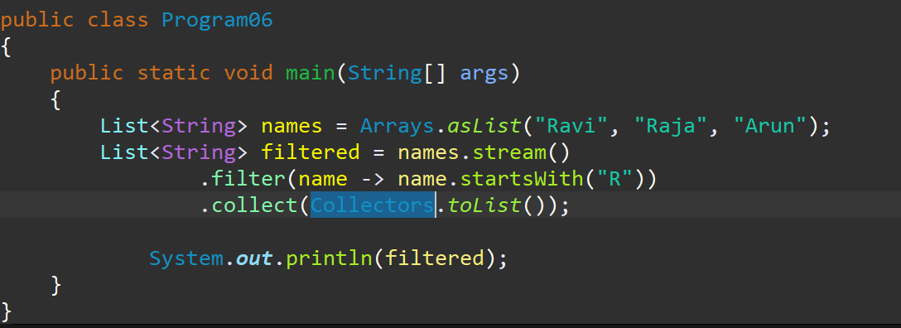

- Functional-Style Immutability:

In functional programming, immutability is important because it prevents side effects and makes the code more predictable and thread-safe.
Example :

List<String> names = List.of("Ram", "Sita"); // Immutable list

List<String> updated = names.stream()
.map(name -> name.equals("Ram") ? "Shyam" : name)
.collect(Collectors.toList());
System.out.println(updated);

- Functional Style:

- Always returns the same result for the same input.
- Has no side effects (it does not modify any external state like variables).

Pure Function using lambda:
---------------------------------------
public static void main(String[] args)
{
// Lambda that behaves like a pure function
Function<Integer, Integer> square = x -> x * x;

System.out.println(square.apply(5)); // 25
System.out.println(square.apply(5)); // 25 (same input -> same output)
}
Impure Lambda:
-----------------------
public class LambdaImpureExample
{
static int count = 0;

public static void main(String[] args)
{
// This lambda modifies external variable — not pure
Function<Integer, Integer> addAndCount = x -> {
count++;
return x + count;
};

System.out.println(addAndCount.apply(5)); // Output depends on external state
System.out.println(addAndCount.apply(5)); // Different result — not pure
}}
Characteristics of Functional Programming
Concept | Description
Pure Functions | Functions that always return the same output for the same input and have no side effects.
Immutability | Data is not modified. Instead, new copies are created with updated values.
Declarative Code | You describe what you want, not how to do it (less control flow, fewer loops).

Imperative vs Declarative
Feature | Imperative | Declarative
Focus | How to do it | What to do
Style | Step-by-step instructions | Describes logic or result
Java 8 Tool | Loops, conditions | Stream API, Lambdas
Code clarity | More code, harder to read | Shorter, cleaner, more readable

Key-features of Java 8
- Functional Interface
- Lambda Expression
- Default Methods in Interfaces
- Static Methods in Interfaces
- Method References
- Optional Class
- Date and Time API (java.time) package
- Collectors
- Stream API
- Parallel Stream

- Functional Interface
- A Functional Interface in Java is an interface that contains exactly one abstract method.
- It can have multiple default and static methods.
- It is the foundation of Lambda Expressions and Method References in Java 8 and later.
  - Advantage of Functional Interfaces :
- They provide target types for Lambda Expressions.
- Reduce boilerplate code
- Enable functional programming in Java.
- Widely used in Streams API

  - Annotations:
- Java provides @FunctionalInterface annotation.
- It’s optional but recommended.
- The compiler will give an error if you add more than one abstract method.
Example :
@FunctionalInterface
interface Calculator {
int calculate(int a, int b);
}
  - Rules of Functional Interface:
- Must have exactly one abstract method.
- Can have any number of default methods.
- Can have any number of static methods.
- Can override methods from java.lang.Object (like toString, equals) – these don’t count as abstract methods.

- Pre-defined Functional Interfaces :
- comparable - int compareTo()
- comparator - int compare(x1 , x2)
- Runnable - void run()
- Functional Interfaces in java.util.function package :
- Single Parameterized Functional Interface
Interface | Method Signature | Usage Example
Predicate<T> | boolean test(T t) | Filtering
Consumer<T> | void accept(T t) | Iterating / printing
Supplier<T> | T get() | Supplying values
Function<T,R> | R apply(T t) | Transforming values
UnaryOperator<T> | T apply(T t) | Single input → same type output

- Two Parameterized Functional Interface
Interface | Method | Input | Output | Usage Example
BiPredicate<T, U> | boolean test(T, U) | T, U | boolean | Compare two values
BiFunction<T, U, R> | R apply(T, U) | T, U | R | Combine inputs to new result
BiConsumer<T, U> | void accept(T, U) | T, U | Void | Perform action on two values
BinaryOperator<T> | T apply(T, T) | T, T | T | Arithmetic operations (sum, max)
In-short term:
Functional Interfaces = Single Abstract Method interfaces → used with Lambda Expressions & Method References → enable functional programming in Java.

